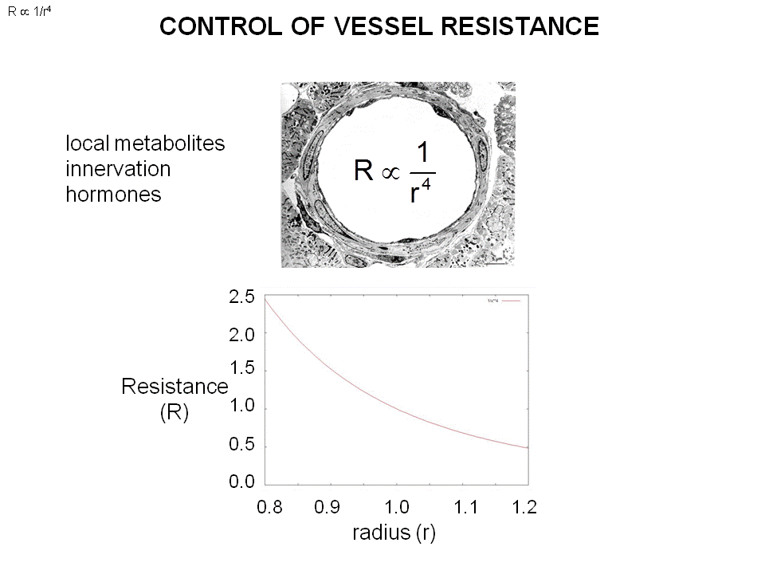

The resistance is inversely proportional to R^2, proportional to V, and L. => the radius influence the Resistance.
- Control the diameter (cross section) in arterial
- The arterial in small artery provide the resistance to flow
- Ex: start exercise ---blood pressure don’t change, the perfusion pressures no change
- But you need the flow to go up without changing the perfusion pressure.
- The resistance of the flow is falling, get dilation of vessel. (The smooth muscle cells (arterial wall) can contract or relax)
- When exercise, the smooth muscle relaxes. The vessels get to be bigger (radius goes up), the resistance drop and the flow goes up.
- The accumulation of waste product act on the smooth muscle to make it relax.
- All the arterials are innervated by autonomic nervous system. This system can make them constrict (or sometimes relax)
- Hormone circulating in the blood (epinephrine, norepine….,) these horomone act on smooth muscle to make it constrict or relax.
- The resistance is inversely proportional to the radius^4, small changes in radius can lead to huge change in resistance.
- Ex :A vessel (r = 1) and the resistance is one
- Increase the radius 20% , now r = 1.2 =>resistance = 0.5 . the 50%fall of the radius caused by 20 5increase in the radius. (Due to r^4)
- Resistance = 1.8, Resistance is 2.5 (increase 150 percent when the radius 20 %increase
- The small change in radius induce huge change in cross section area and he resistance.
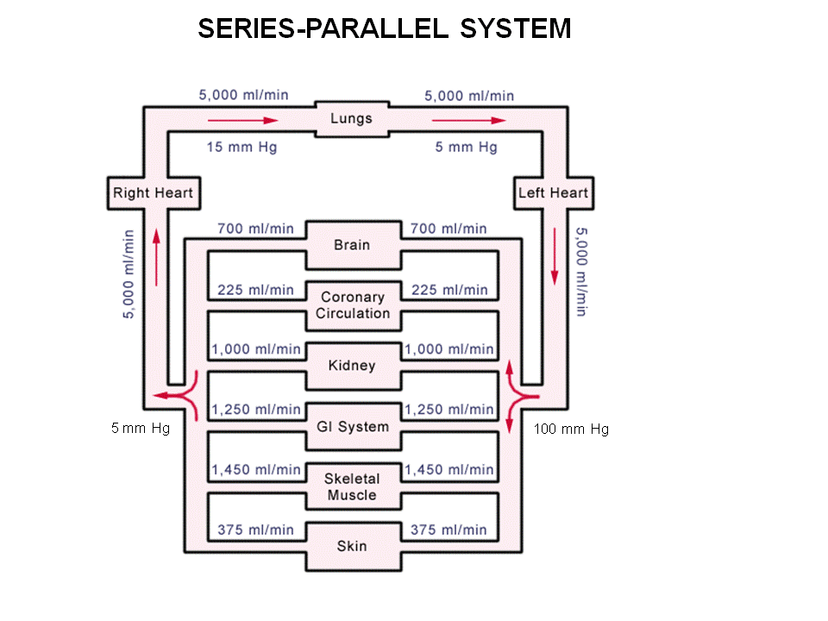
The cardiovascular system is in series (parallel)

Right heart in series with the lungs = they hooked together, everything leaves the right heart go through the lungs. The blood comes in the right lungs by pulmonary track, the flows out.
- The flows are in parallel with each other in two lungs.
- Same idea in systemic circulation
All the systemic is parallelto each other.
- so the total flow, is the sum of these flows.
- The have the same perfusion pressure. (Arterial blood pressure – veins pressure.) All the organs are fed by large arteries to large veins.
- They are all in parallel, the flow through is different , but the perfusion pressure is the same.
- The perfusion pressure across are the same across kidney and brain, but the flow is less in brain than in kidney.
- We can tell the resistant is higher in the brain, Flow (different) = perfusion pressure (same) /resistance (different). Must memorize this equation.
- think V (PERFUSION PRESSURE )= I (FLOW ) /R( RESISTANCE)
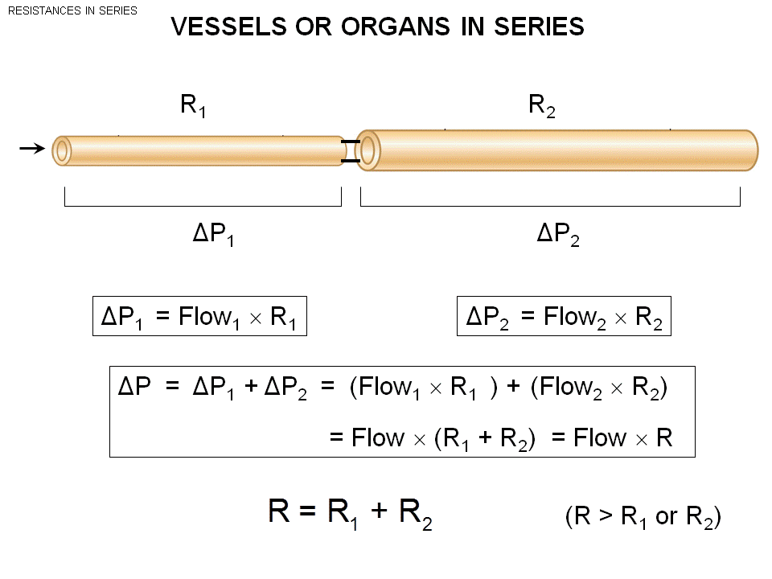
The vessels are in series.
- When the vessels branches , the mother vessel is in series with the daughter vessels.
- The whole cardiovascular tree is a group of series and parallel.
In series the resistance goes up. In parallel the resistance goes down. (Same with the electricity )
The total flow to the system, is the same everywhere in series.
Perfusion pressure = flow * resistance.
- Want to know the overall resistance in the two vessels
- Replace the whole thing by a single vessel, what will the resistance of this vessel be?
- R:
- P (perfusion pressure is the sum of the two ) =delta P1 + delta P2. = (flow *R1) +(Flow* R2)
- Flow 1 = flow 2 (flow the same through a single vessel) , so the resistance of the combine system =R1 + R2
- So when add two vessels in series, the combined resistance is the sum of the two.
- This means when put things in series , the overall resistance increase.
Instead of a branching vessel, If the blood come from aorta goes through the whole body, the resistance of this vessel will be huge resistance 9Resistance is directly proportional to the length, you can also think all the small vessel get stick together end up a huge resistance. )
One of the reason we don’t have only one single vessel, the cardio out put(the pump) need to be huge to give enough flow to the resistance of a long vessel.

The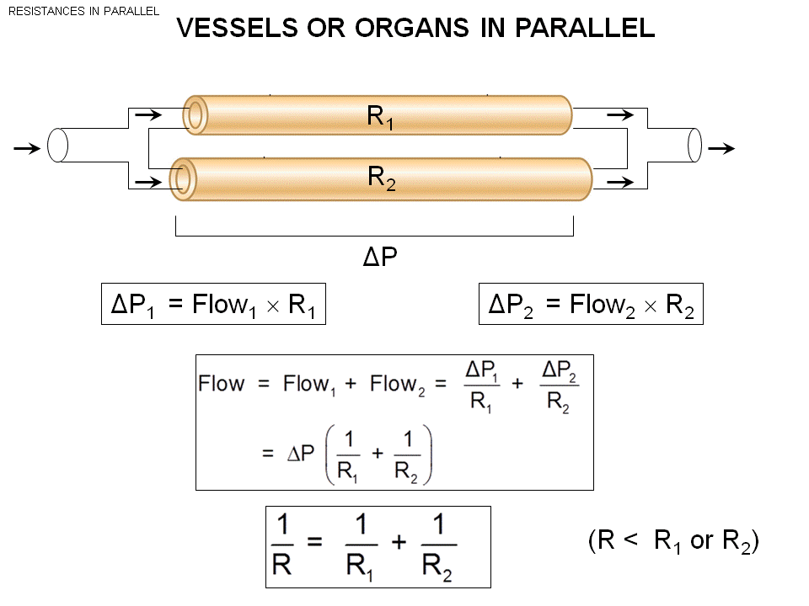

In Parallel, only when R1 = R2 the flow will be the same.
The overall flow = Flow1 +flow 2 , the perfusion pressure is the same across the parallel.
- When things are parallel
- The overall flow = perfusion pressure *(1/R1+ 1/R2) == flow = perfusion pressure/R
- 1/R = 1/R2+ 1/R2.
- So when things put in parallel the resistance is less
- Another way to think: when put two things in parallel, increase the cross section so the resistance fall.
- When arterial branches give the lower resistance
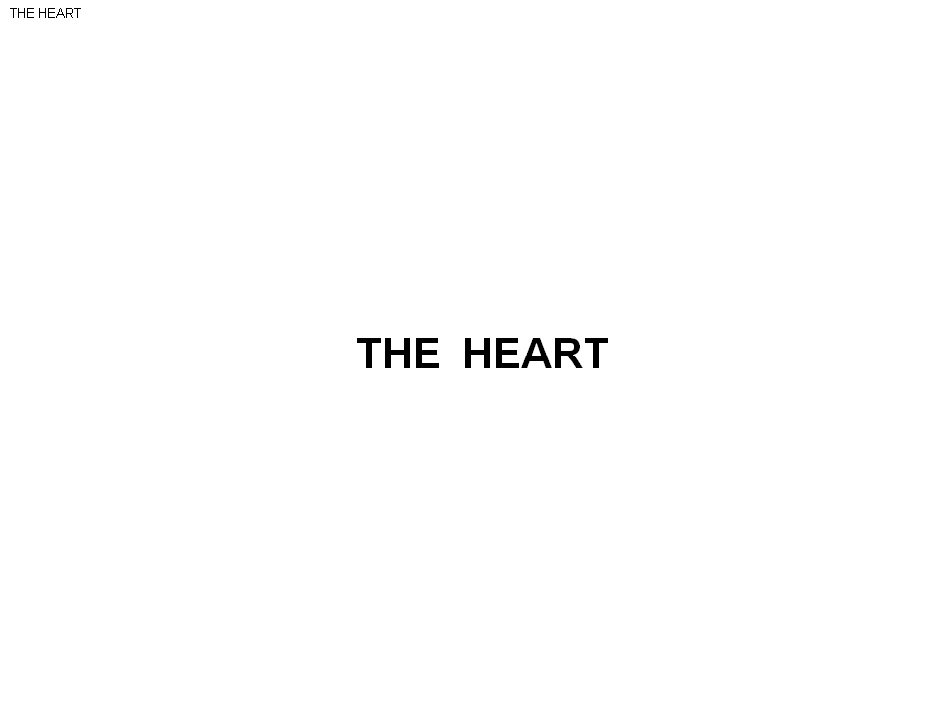
-Anatomy

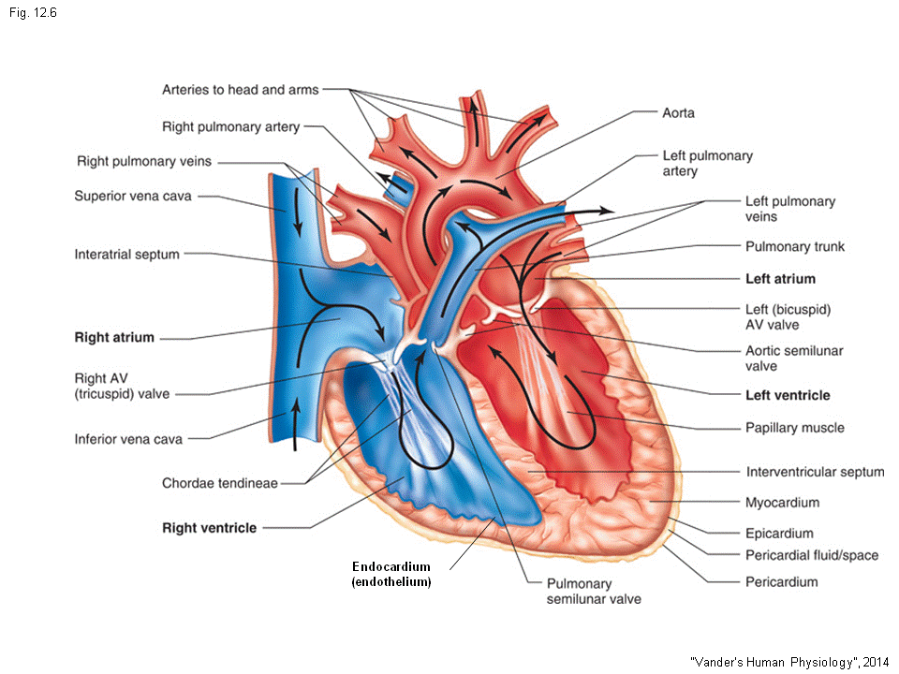

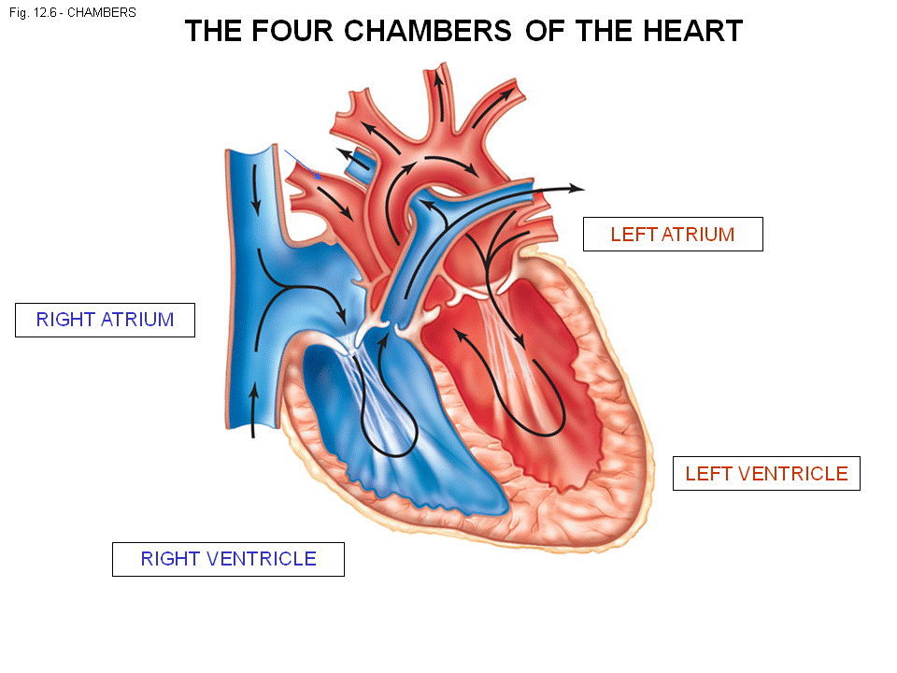
- Heart:
- 4 chambers
- 2 heart : left and right heart.
- The chamber that blood comes into the heart: atrium
- The chamber that the blood leave: ventricle

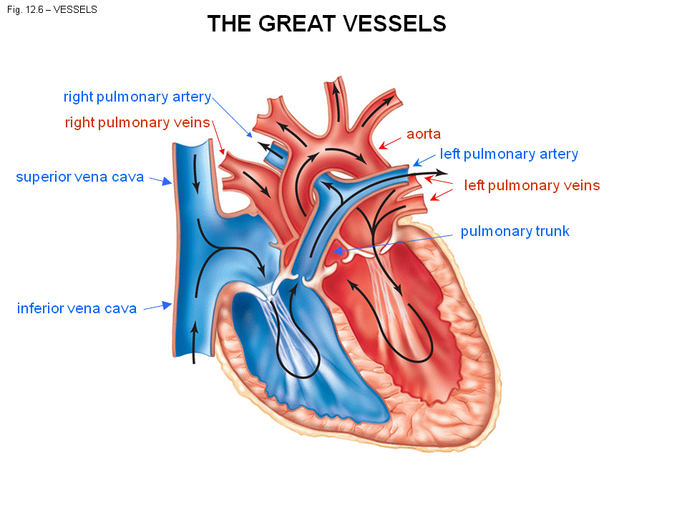

- Every time hear t beats, the blood go to the left ventricle. Oxygenated blood comes from the left ventricle to the aorta feed the body.
- Go up or go down.
- The blood get back to right atrium (pleural is atria), lower part comes back through inferior vena cava. The upper part comes through the superior vena cava. Both ends up in the right atrium.
- The left atrium, blood comes back through the 2 pulmonary veins, there is 2 left and 2 right pulmonary vein. (There is 2 veins coming back from each of the lungs.) to bring the blood back to left atrium.
- Right ventricles pump out deoxygenated blood though the pulmonary trunk. This divide to left and right pulmonary arteries (each go to left or right lungs ). These are the great vessels (large cross section area) they have to carry the entire cardio output to the lungs.

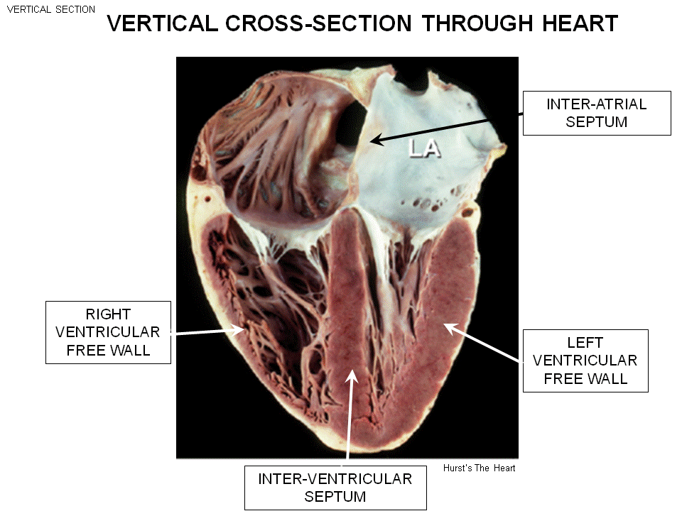
LA = left atrium
The inter ventricular septum (thick muscle) separate the left and right ventricle space.
The wall called inter-atrial septum (a piece of muscle) separate the right and left atrium.
The septum means the inter ventricular septum.
The free wall, is a lot thicker on the right.
-the reddish brown color is muscle (cardiac muscle)
On the right free wall, we can see the cardiac muscle.
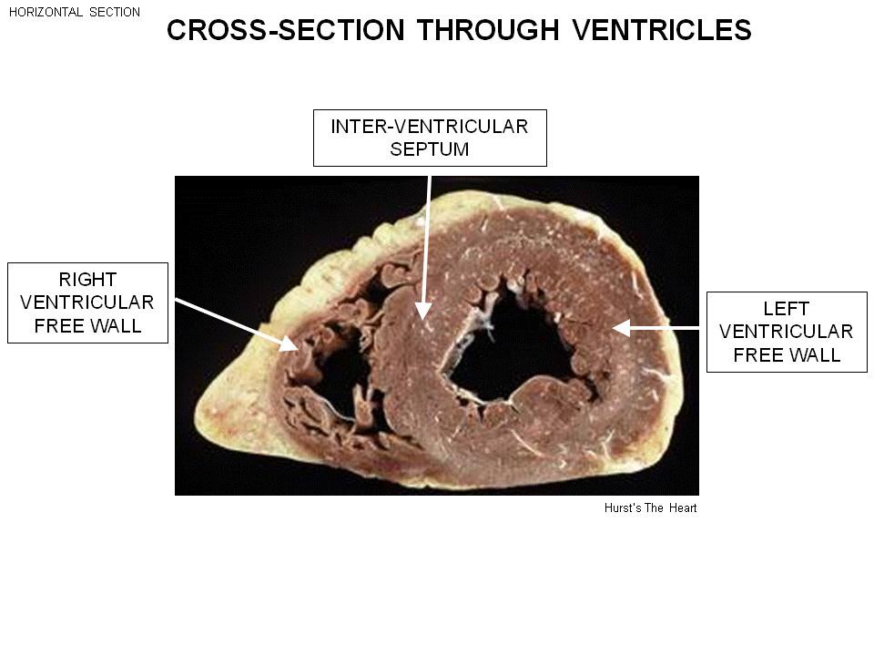

- The blood comes through the left atrium goes through the left ventricle.
- The cross section, anything in the right stays right. (The left will stays left )
- These are completely different pieces (that’s why we said two hearts.)
The right and left is completely different pieces.
- The left able to create a huge force.
- The right isn’t able to create that much force.

Interventricular pressure (the pressure inside the ventricle):
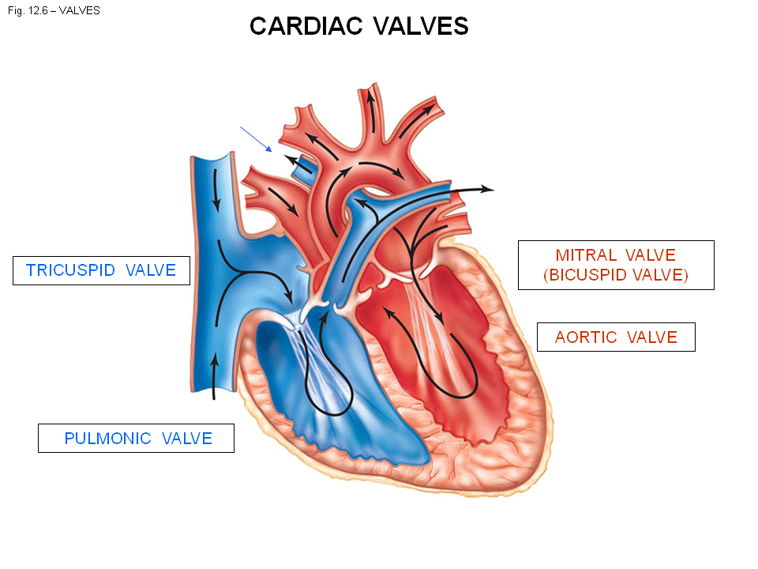
- The left ventricle contract 100mmHG, the right 10 mmHg.

There is a total 4 valves.
- Two states of valves : open/closed
- The vales is one way
- allow the blood to flow in only one direction.

- Atrial-ventricular vales: It’s the junction between atrial and ventricle.
- The one on the right is called: tricuspid valve
- The one on the left is called: Mitral valve

- The valves in the output of ventricle
- The one on the left, this is the valve between the left ventricle and the aorta: Aortic valve
- The one on the right, the junction between right ventricle and pulmonary trunk: Pulmonic valve

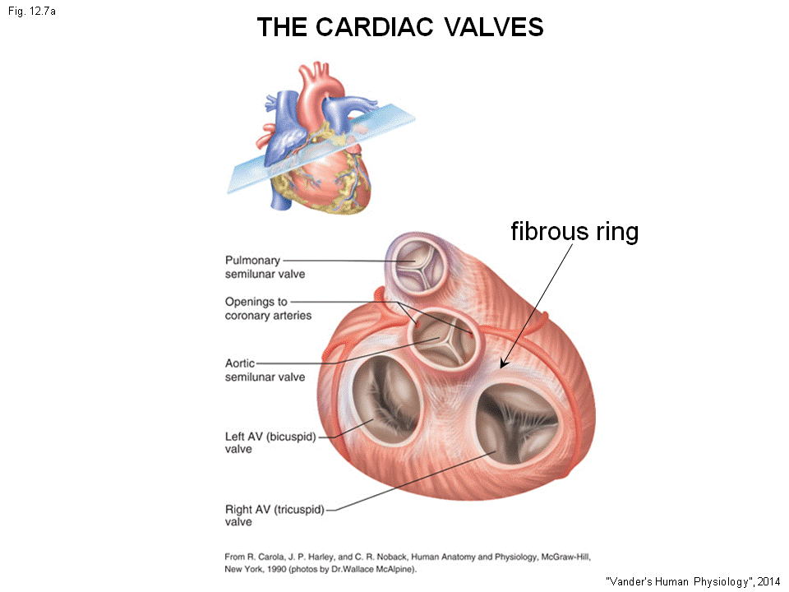
- this shows the 4 valves.
Tricuspid valve on the right:
3 independent cusps (tricuspid)
- When the valve is open: 3 will move together to separate
- When closed: 3 cusps will closed together.
the left AV valve is bicuspid valve:
- Only two cusps
The pulmonary/aortic valve:
- Mostly 3 cusps.
The tricuspid valve refers to the right AV valve.

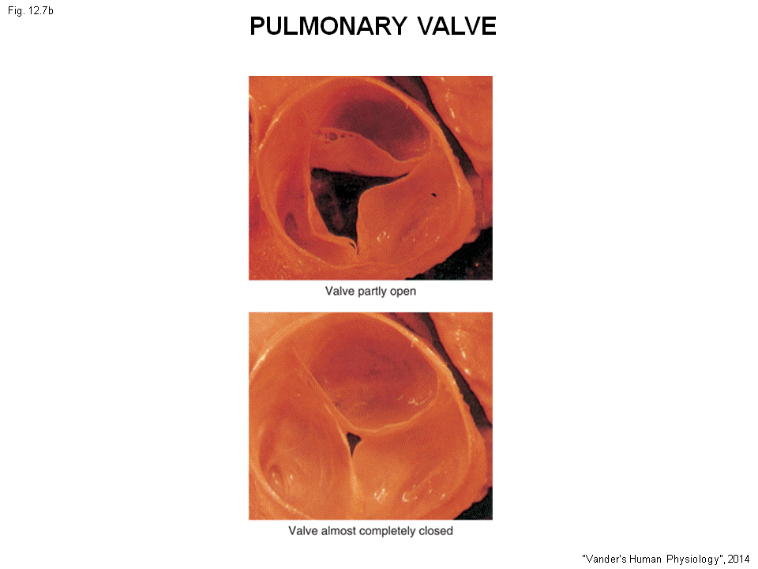
The upper is open, down is closed (blood well not able to get through from chamber to chamber or to vessels.)

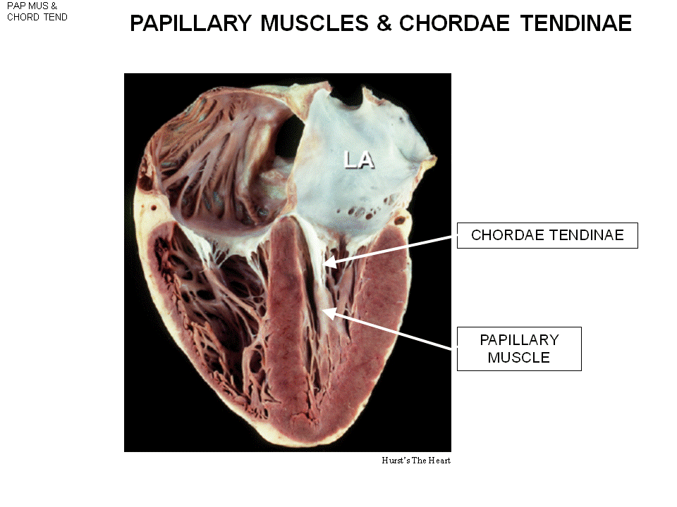
The valves are connective tissue (fibrous ring).
-Action potential run through the atrium muscle, then ventricular muscle.
- They can’t get from atrium muscle to ventricle muscle due to this connective tissue block (not excitable tissue).
- There is small pieces of connective tissue that allow potential pass down. (next class) - - - The strings of the valves calls chordate tendinae (act as tendons)
this thing connect the papillary muscles.
- The papillary muscle is the outgrowth of the wall/septum.
When left ventricle contacts, pressure goes up. The blood should go to the aorta, and can’t go to the atrium. The arrangement of these will prevent this happen.
- Remember, they are thin and can move easily.
- The atrium contracts, the ventricle contract. When the ventricle (100mmHg) contract, the pressure of the atrium is very small (10 cmH2O). This valve is thin and can be pushed up to atrium. (This can’t happen!!) The blood in this case can go back to atrium.
- The papillaries muscle are part of ventricular muscle, so when ventricle start to contract. The papillary muscle also start to contract. muscle shorten, pull the chordate tendinae down the chordate tendon are connect to the flat valves pulls the valves down and make sure the high pressure of ventricle doesn’t push it up to atrium.
- The valves close , the blood is now able to go to the lungs or the body.
- When heart attack, if papillary muscle die, the blood will go back if the ventricular muscle contract.

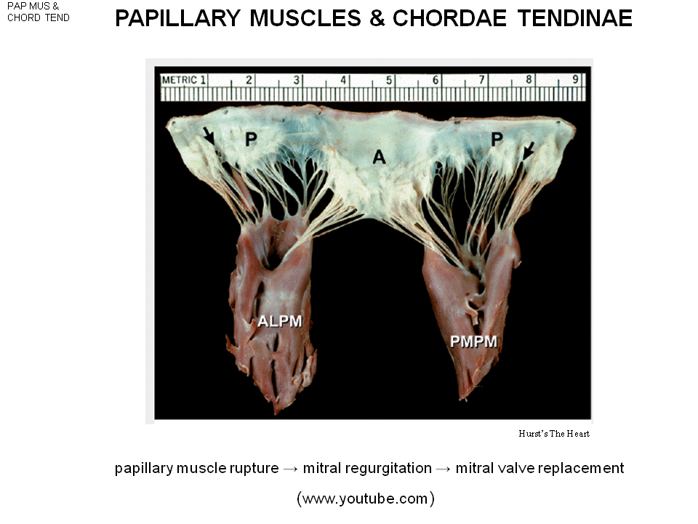
The branches inset to the valves.
Mitral regurgitation, == a flow in the opposite direction. (the blood is sent back)
-need a artificial valve

Endocardium – the entire inside part of heart is lined with a layer of endothelium cell.(ex: the white stuff in left atrium) the lining line up all the cardiovascular system. All the vessels (except the capillaries) is lined by endocardium (the endothelial cell.)
- Epicardium, lining outside the muscle cell of the heart
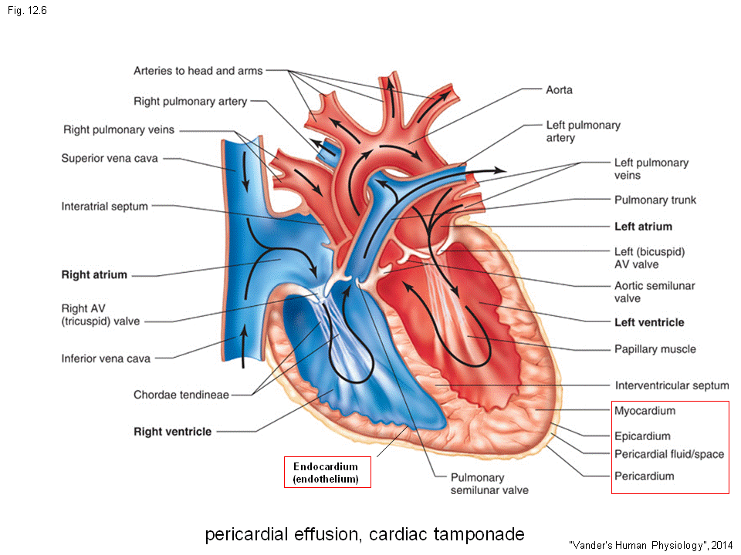
- Pericardial sac : the whole hearts sits in. (These is a tough cardio fiber sac that the heart sits in)
Percardial space have the fluid (small amount of fluid) This fluid lubber, so that when heart contract, it won’t rub the sac.
Abnormal: If the space accumulate fluid (the sac won’t move, it is a tough structure where the heart sits), the right or left ventricle will be pushed inward. Squeeze the heart. Heart will be compress with less volume.
- If less blood pumps in, less blood pumps out. Cardiovascular can fail. (Can kill you)
Pericardial effusion produce cardiac tamponade (the heart is pushed )
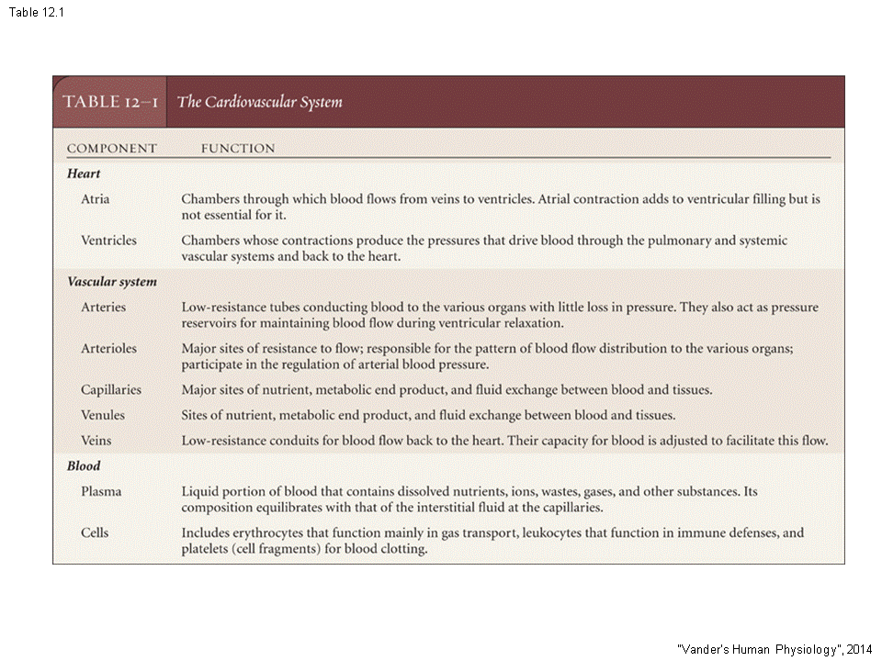
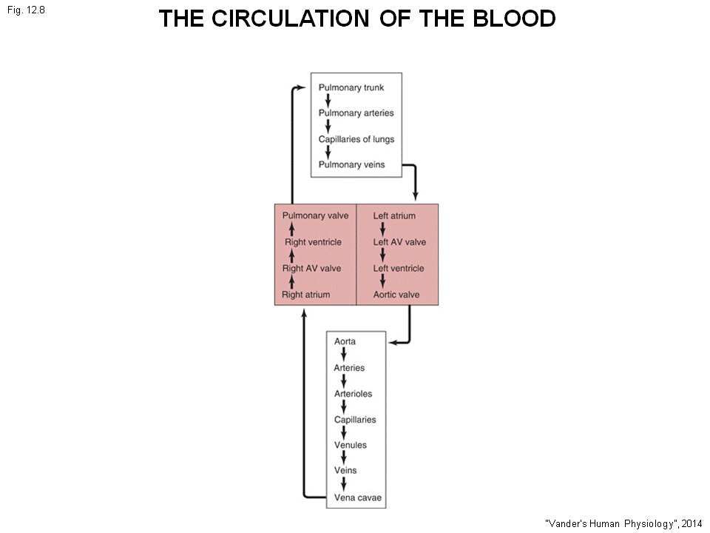
The circulation of the blood. Oxygenated blood to left atrium across the valve to the left ventricle , aorta ……….. vena cave ( deoxygenate ) right atrium , across right ventricle pulmonary arterial…..(on pic)

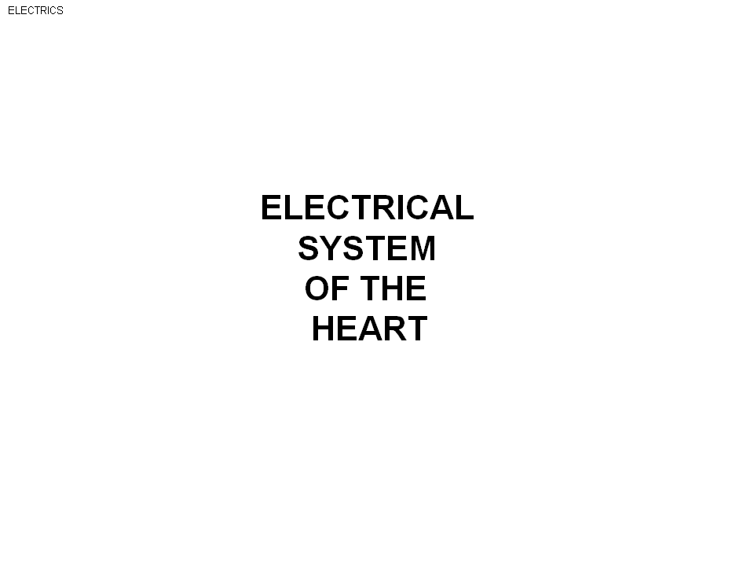
Electrical system of the heart.
- The muscle contract need action potential, same with the heart .
- The heart is cardiac myocyte
- The action potential comes down to the cells, cause Ca+ influx and contract eventually.
- In sequence: We want the atrium to contract than the ventricle to contract.
- If atrium and ventricle contract at the same time -not good
- The activation sequence in heart, the action potential is move in the sequence.
- Our heart is a cardiogenic heart.
- The insects: neurogenic heart: heart only beat when brain sends down action potential. (Heart beat is driven by neuron system)
- Our heart is a cardiogenic heart, the heart is beating with out brain. The origin of heat beat is inside the heart itself.
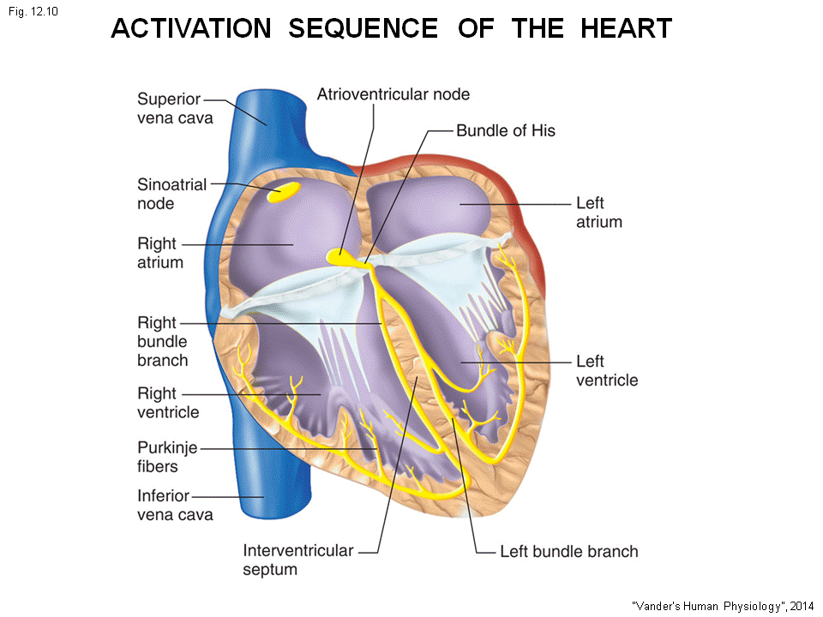
- Sinoatrial node in the right atrium, if isolate single cells: these are specialized muscle cell, you can see them beating under microscope. Also called “pace maker cells “
- Sinoatrial node fire action potential spontaneous in one second. This potential spread throughout the right atrium muscle and throughout the left atrium muscle.
- The depolarization wave comes off the sinoatrial node, block from go down the ventricles by the valves (the fibrous ring, connective tissue.)
- Another specialized cardiac muscle called” Atrioventricular nodes”, its in the junction of atrium and ventricle (cardio junction). This action potential than moves through the AV nodes to the bundle of His break to two bundles (left and right bundles), these bundle branches to the fine networks (called Purkinje fibers.)
All the stuff in yellow are specialized system, these are not neuron!!! These are cardio muscle cell whose function is not to contract but to simply start the action potential and then conducted the wave to the entire heart.
- This is the purkinje network in ventricle, this bundle branches break into smaller fibers and end up in the endocardial muscle on the inside part of the heart . The action potential then travel through the wall of the heart , (from inside to outside –from the endocardial muscle to the pericardial muscle )
- This is happen in the simultaneous wave on both left and right. (that’s why there is two bundles of branches left and right, so the action potential comes down at the same time and both ventricle contract at the same time
This is the specialize conducting system in the heart.

